Practical 1

TCP/UDP scanning using NMAP and ZENMAP

Aim: Scan a single IP

Syntax: nmap ip address

It will scan 1 ip address in which it will search for open ports and services foe the MAC address provided.

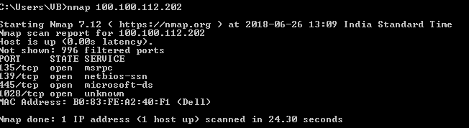

Aim: Scan a range of IP address

Syntax: nmap ipaddress-ipaddress

EG: nmap 100.100.112.200-210

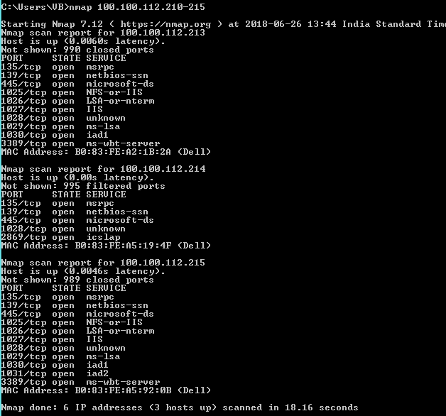

Aim: Scan a subnet

Syntax: nmap ipaddress/subnet

EG: nmap 100.100.112.202/24

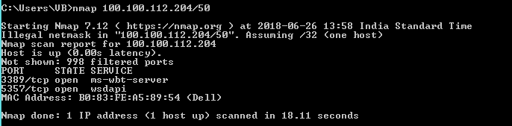

Aim: Scan a single port

Syntax: nmap –p portname ipaddress

EG: nmap –p 80 100.100.112.202

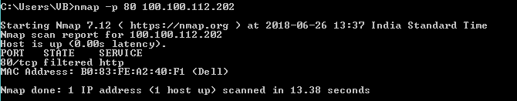

AIM: To find information about the operating system

Syntax: nmap –O -ipaddress

Nmap –O 100.100.112.202

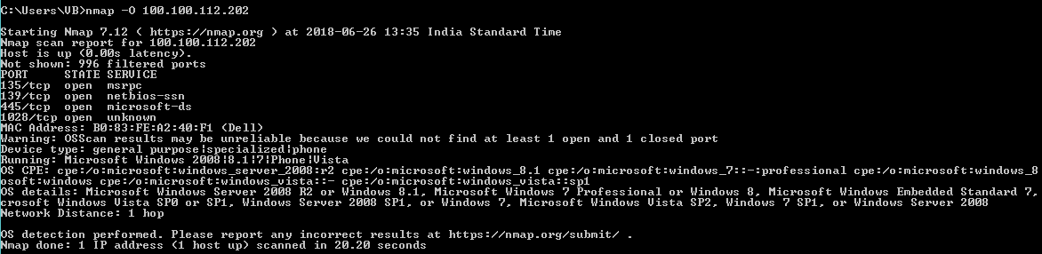

AIM: To find the range of ports

SYNTAX: nmap –p portrange ipaddress

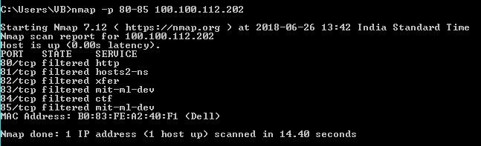

AIM: To scan all the ports

SYNTAX: nmap –p ipaddress

EG: nmap –p 100.100.112.202

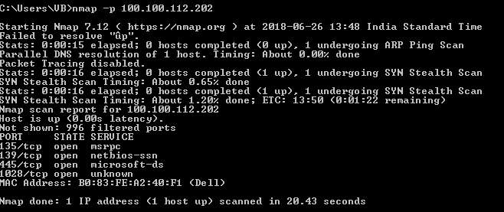

AIM: To find first 100 most common ports

SYNTAX: nmap –f ipaddress

EG: nmap –f 100.100.112.202

